**Smart Methods**

**Task 1: Install Ros & Ubuntu**

1. Text

   Description automatically generated with low confidenceGo to <https://www.virtualbox.org/> to install virtual machine
2. 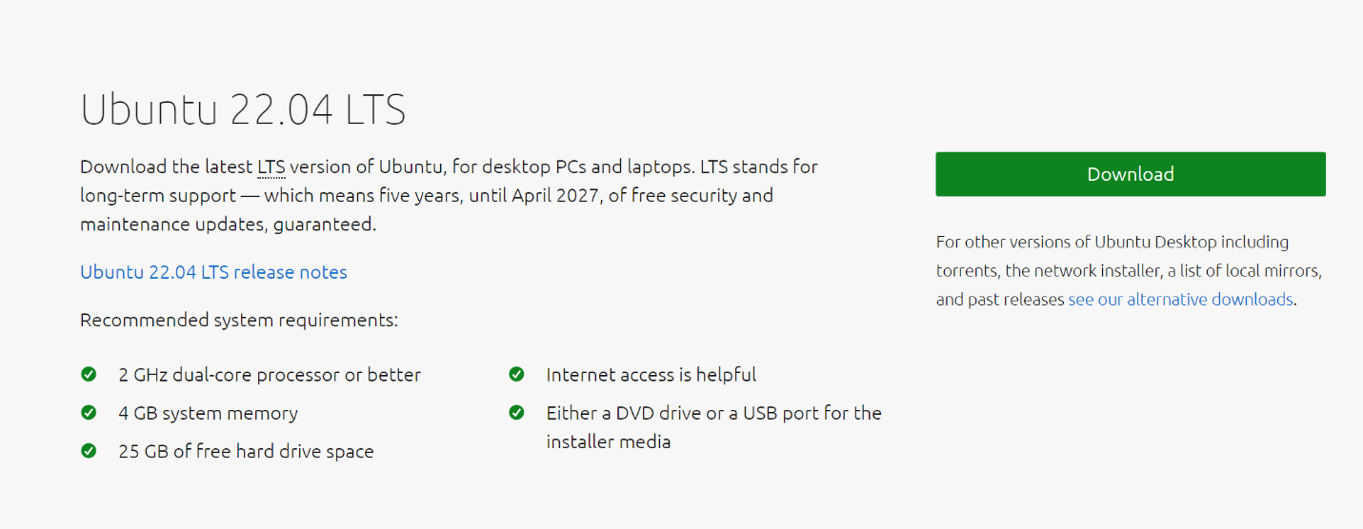Go to <https://ubuntu.com/download/desktop> to install Ubuntu

* Reference for the whole tutorial for Ubuntu installation: <https://youtu.be/x5MhydijWmc>

1. Graphical user interface, text, application, email

   Description automatically generatedDownloading Ros on virtual machine by applying these commands on Ubuntu terminal <http://wiki.ros.org/noetic/Installation/Ubuntu>

* Checking that ROS is installed by connecting to the master node

Task 2: Install Ros2 foxy on Jetson Nano

1. Go on <https://docs.ros.org/en/foxy/Installation/Ubuntu-Install-Debians.html#id8> for installing ROS2-foxy
2. Enter the commands in Ubuntu or install Xubuntu

* Test if its Installed by these commands: Graphical user interface, text, application, email

  Description automatically generated

* Download Balena for jetson nano

<https://www.balena.io/etcher/>